**LAB ASSIGNMENT 1**

1. **WAP which will format console output using '\n', '\t', '\b' within printf statement**.

**INPUT**

#include<stdio.h>

int main()

{

printf("NEW LINE\n");

printf("TABSPACE \t");

printf("BACKSPACE \b");

return 0;

}

**OUTPUT**

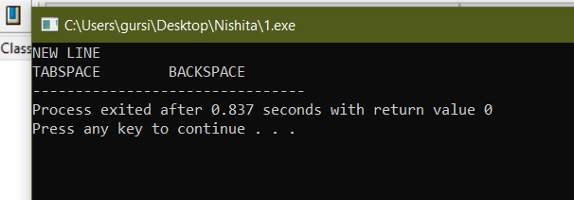

**2.WAP to print ‘See C is Sea’ five times on the console.**

**INPUT**

#include<stdio.h>

int main()

{

printf("See C is Sea\n");

printf("See C is Sea\n");

printf("See C is Sea\n");

printf("See C is Sea\n");

printf("See C is Sea\n");

return 0;

}

**OUTPUT**

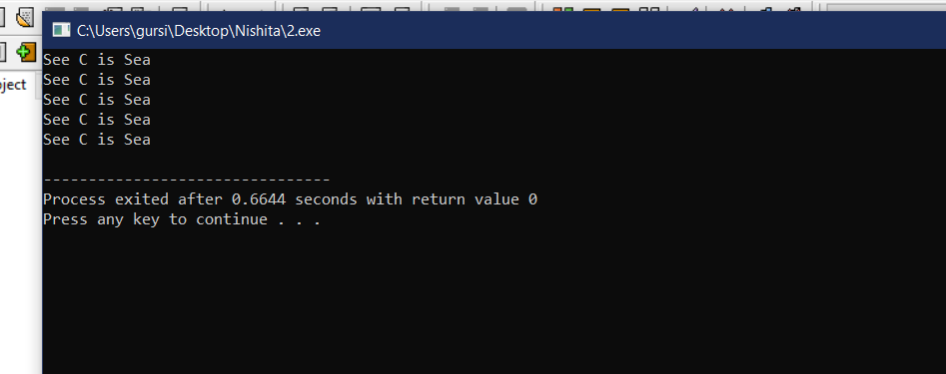

**3. WAP which will accept an integer, a decimal number, a character and a string from the keyboard and display them one per line.**

**INPUT**

#include<stdio.h>

#include<string.h>

int main()

{

int a;

float b;

char c,d[10];

printf("Enter an integer\n");

scanf("%d",&a);

printf("Enter a decimal number\n");

scanf("%f",&b);

printf("Enter a character\n");

scanf(" %c",&c);

printf("Enter a string\n");

scanf(" %s",&d);

printf("Integer-%d\nDecimal Number-%f\nCharacter-%c\nString-%s",a,b,c,d);

return 0;

}

**OUTPUT**

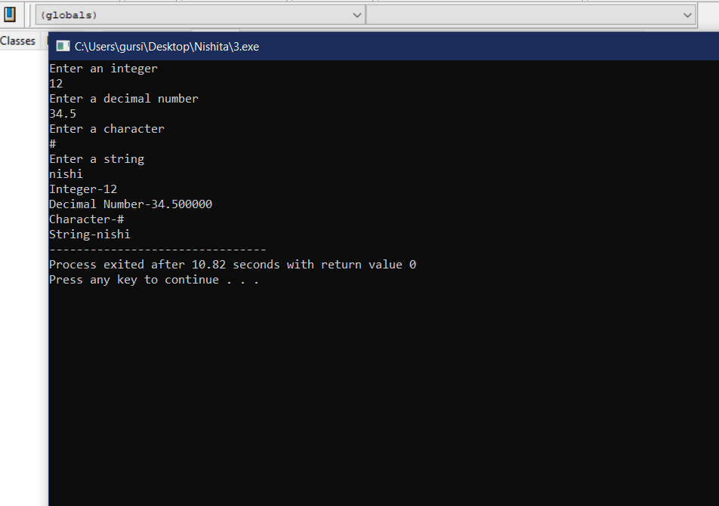

**4. WAP that will print your mailing address in the following format**

**First line : Your Name**

**Second line : House No, Street**

**Third line : City**

**Fourth line : State, Pin code**

**INPUT**

#include<stdio.h>

int main()

{

char city[15],name[15],state[15],street[20];

int pincode,houseno;

printf("Enter the following Details\n");

printf("Enter your:\nName\nHouse Number\nStreet\nCity\nState\n");

scanf("%s%d %s %s %s",&name,&houseno,&street,&city,&state);

printf("Enter your 6 digit pincode\n");

scanf("%d",&pincode);

printf("Name\t\t\t:\t%s\nHouse Number,Street\t:\t#%d,%s\nCity\t\t\t:\t%s\nState,Pincode\t\t:\t%s,%d",name,houseno,street,city,state,pincode);

return 0;

}

**OUTPUT**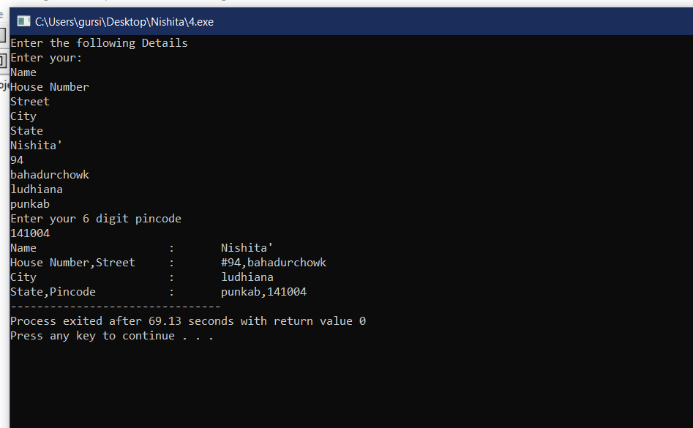

**5. WAP which will accepts two integers (a and b) from the input device and display the results of**

**their sum, difference, product, division and mod on the console by assuming a simple arithmetic**

**calculator.(INTEGER**)

**INPUT**

#include<stdio.h>

int main()

{

int a,b,mod,sum,diff,pro,div;

printf("Enter two numbers\n");

scanf("%d%d",&a,&b);

sum=a+b;

diff=a-b;

pro=a*b;

div=a/b;

mod=a%b;

printf("Sum=%d\nDifference=%d\nProduct=%d\nDivision=%d\nModulus=%d",sum,diff,pro,div,mod);

return 0;

}

**OUTPUT**

**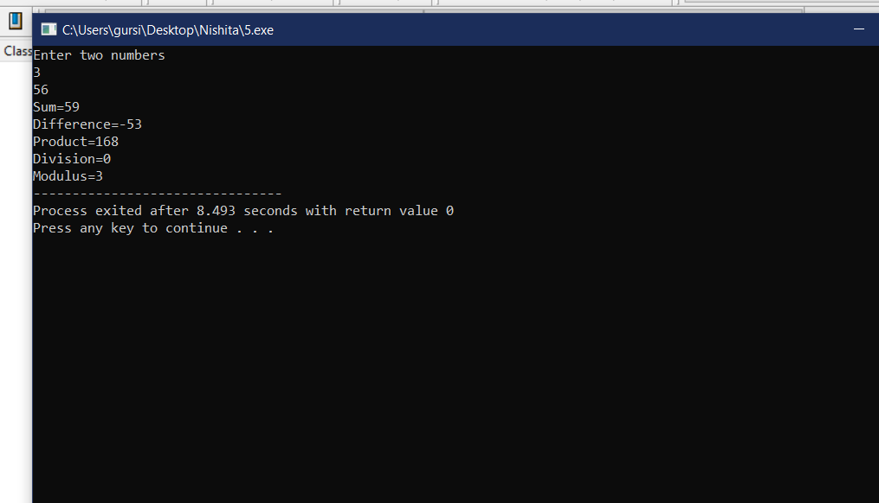  
5. WAP which will accepts two integers (a and b) from the input device and display the results of**

**their sum, difference, product, division and mod on the console by assuming a simple arithmetic**

**calculator.(DECIMAL)**

**INPUT**

#include<stdio.h>

int main()

{

float a,b,sum,diff,pro,div;

printf("Enter two numbers\n");

scanf("%f%f",&a,&b);

sum=a+b;

diff=a-b;

pro=a*b;

div=a/b;

printf("Sum=%f\nDifference=%f\nProduct=%f\nDivision=%f",sum,diff,pro,div);

return 0;

}

**OUTPUT**

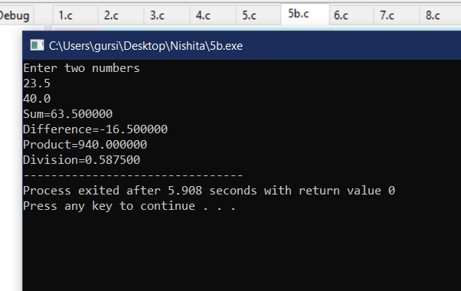

**6. WAP which will compute the simple and compound interest and display them on the console.**

***INPUT***

#include<stdio.h>

#include<math.h>

int main()

{

float SI,CI;

int P,R,T,Q;

printf("Enter Principle Amount,Rate,Time\n");

scanf("%d%d%d",&P,&R,&T);

SI=P*R*T;

Q=1+R/100;

CI=P*pow(Q,T)-P;

printf("Simple Interest=%f\nCompound Interest=%f",SI,CI);

return 0;

}

**OUTPUT**

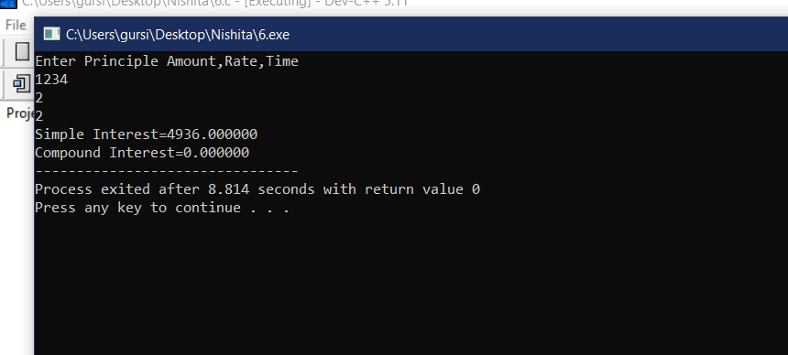

**7. WAP that reads the values of three variables a, b and c from the input device and then compute and display the value of d, where d = (a-b)/(b+c).**

**INPUT**

#include<stdio.h>

int main()

{

float a,b,c,d;

printf("Enter 3 variables\n");

scanf("%f%f%f",&a,&b,&c);

d=((a+b)/(b-c));

printf("%f",d);

return 0;

}

**OUTPUT**

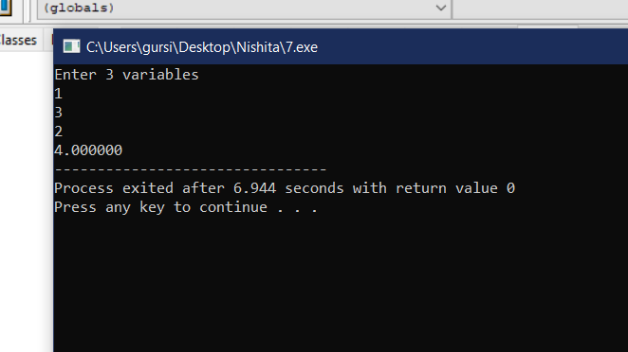

**8. Relationship between Celsius (C) and Fahrenheit (F) is governed by the following formula**

**F = 9C/5 + 32 WAP to convert the Celsius to Fahrenheit and vice versa.(C TO F)**

**INPUT**

#include<stdio.h>

int main()

{

float C,F;

printf("Enter the value of celsius scale\n");

scanf("%f",&C);

F=((9*C/5)+32);

printf("%fF",F);

return 0;

}

**OUTPUT**

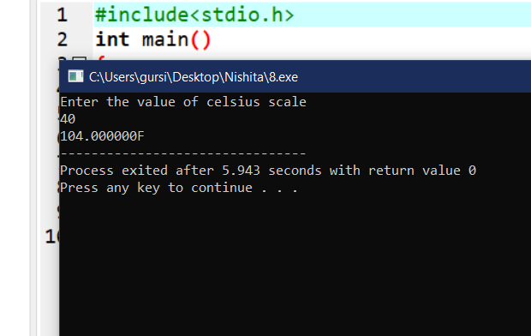

**8. Relationship between Celsius (C) and Fahrenheit (F) is governed by the following formula**

**F = 9C/5 + 32**

**WAP to convert the Celsius to Fahrenheit and vice versa.(F TO C)**

**INPUT**

#include<stdio.h>

int main()

{

float F,C;

printf("Enter the value of farenheit scale");

scanf("%f",&F);

C=((F-32)*5/9);

printf("%fC",C);

return 0;

}

**OUTPUT**

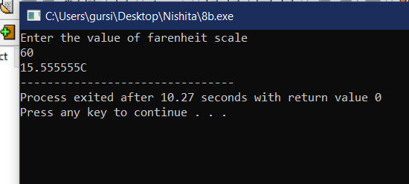

**9. Area (A) of a triangle is given by the formula = Where a, b and c are sides of the triangle and 2S = a + b + c. WAP to compute the area of the**

**triangle given the values of a, b and c.**

**INPUT**

#include<stdio.h>

#include<math.h>

int main()

{

int a,b,c;

float S,Area;

printf("Enter the sides of the triangle\n");

scanf("%d%d%d",&a,&b,&c);

S=(a+b+c)/2;

Area=sqrt(S*(S-a)*(S-b)*(S-c));

printf("Area=%f",Area);

return 0;

}

**OUTPUT**

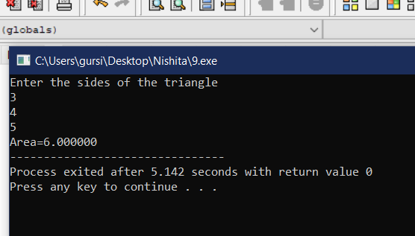

**10. The line joining the points (2, 2) and (5, 6) which lie on the circumference of a circle is the**

**diameter of the circle. WAP to compute the area and perimeter of the circle**.

**INPUT**

#include<stdio.h>

#include<math.h>

int main()

{

int x,x1,x2,y,y1,y2;

float cir,area,dia,rad;

printf("Enter the x axis end points of diameter\n");

scanf("%d%d",&x1,&x2);

printf("Enter the y axis end points of diameter\n");

scanf("%d%d",&y1,&y2);

x=x2-x1;

y=y2-y1;

dia=sqrt(pow(x,2)+pow(y,2));

rad=dia/2;

area=M_PI*pow(rad,2);

cir=2*M_PI*rad;

printf("Area=%f\nCircumference=%f",area,cir);

return 0;

}

**OUTPUT**

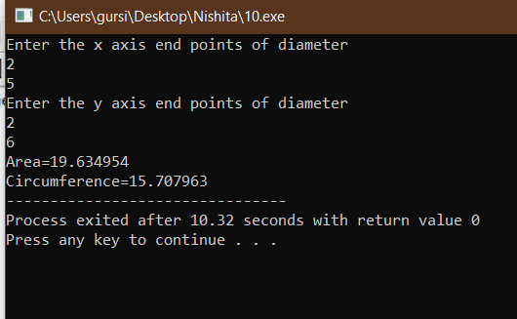

**Lab Assignment 2**

**1. WAP to compute the gross salary of an employee whose details are given below:**

**Basic pay: Rs.50, 000, dearness allowance: 50% of Basic pay, house rent allowance: 20% of Basic**

**pay, vehicle allowance: 10% of the Basic pay.**

**INPUT**

#include<stdio.h>

int main()

{

int bp;

float da,hra,va,gs;

bp=50000;

da=0.5*bp;

hra=0.2*bp;

va=0.1*bp;

printf("Basic Pay=50,000\nDearness Allowance=%f\nHouse Rent Allowance=%f\nVehicle Allowance=%f\n",da,hra,va);

gs=bp+da+hra+va;

printf("Gross Salary=%f",gs);

return 0;

}

**OUTPUT**

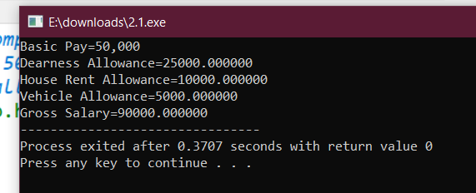

**2. The price of one pen is Rs.10, one pencil is Rs. 5, and one sharpener is Rs. 2. You purchased 2**

**pens, 3 pencils and 1 sharpener. Compute the total price as per the following format.**

**\*\*\*\*\*\* LIST OF ITEMS \*\*\*\*\*\***

**Item Price (Rs.) Total (Rs.)**

**Pen 10 20**

**Pencil 5 15**

**Sharpener 2 2**

**Grand Total (Rs.) 17 37**

**INPUT**

#include<stdio.h>

int main()

{

int pen=10,pencil=5,sharp=2,p,pi,s,to,t;

p=2*pen;

pi=3*pencil;

s=1*sharp;

t=pen+pencil+sharp;

to=p+pi+s;

printf("Item\t\t Price(Rs.)\tTotal(Rs.)\nPen\t\t%d\t\t%d\nPencil\t\t%d\t\t%d\nSharpner\t%d\t\t%d\nGrand Total(Rs.)%d\t\t%d",pen,p,pencil,pi,sharp,s,t,to);

return 0;

}

**OUTPUT**

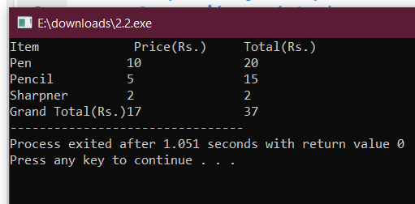

**3. WAP which will print the ‘$’ symbol in the following format. (Hint: No need to use any loops)**

**$**

**$ $**

**$ $ $**

**$ $ $**

**$ $ $**

#include<stdio.h>

int main()

{

printf("$\n");

printf("$\t$\n");

printf("$\t$\t$\n");

printf("$\t$\t$\n");

printf("$\t$\t$\n");

return 0;

}

**OUTPUT**

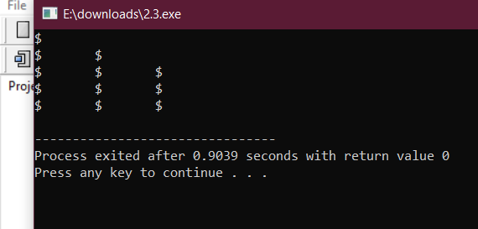

**4. WAP which will accept two floating point numbers, assign their sum to an integer variable and**

**then output the values of all three variables.**

**INPUT**

#include<stdio.h>

int main()

{

float a,b;

int c;

printf("Enter the values for summation\n");

scanf("%f%f",&a,&b);

c=a+b;

printf("%f+%f=%d",a,b,c);

return 0;

}

**OUTPUT**

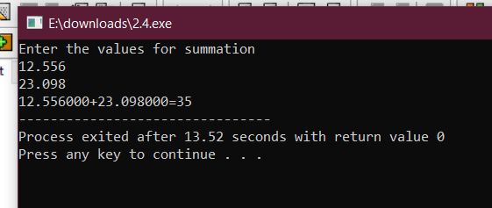

**5. WAP to swap two numbers using and without using a third variable.(WITHOUT THIRD VARIABLE)**

**INPUT**

#include<stdio.h>

int main()

{

int a,b;

printf("Enter the two numbers\na=");

scanf("%d",&a);

printf("b=");

scanf("%d",&b);

a=a+b;

b=a-b;

a=a-b;

printf("After Swapping\na=%d\nb=%d",a,b);

return 0;

}

**OUTPUT**

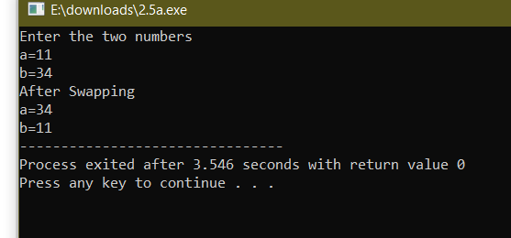

**5. WAP to swap two numbers using and without using a third variable.(USING THIRD VARIABLE)**

**INPUT**

#include<stdio.h>

int main()

{

int a,b,c;

printf("Enter the numbers:\na=");

scanf("%d",&a);

printf("b=");

scanf("%d",&b);

c=a;

a=b;

b=c;

printf("Numbers after swapping:\na=%d\nb=%d",a,b);

return 0;

}

**OUTPUT**

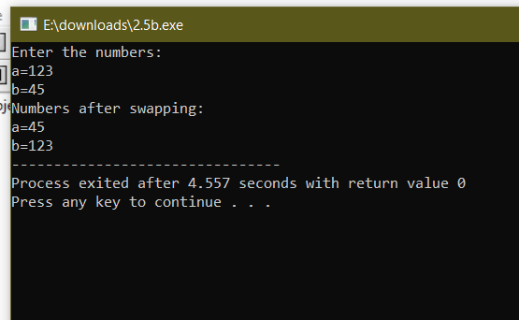

**6. Extend the above program for three variables a, b, and c such that a holds the value of c, b holds**

**the value of a, and c holds the value of b using and without using a third variable.(WITHOUT VARIABLE)**

**INPUT**

**OUTPUT**

**6. Extend the above program for three variables a, b, and c such that a holds the value of c, b holds**

**the value of a, and c holds the value of b using and without using a third variable.(WITH THIRD VARIABLE)**

**INPUT**

**OUTPUT**

**7. WAP which will accept a three digits integer number and display the sum and product of all the**

**digits of that number. (Hint: Use / and % operators)**

**INPUT**

#include<stdio.h>

int main()

{

int a,b,c,sum,pro;

printf("Enter a 3 digit number");

scanf("%d",&a);

b=a/100;

a=a%100;

c=a/10;

a=a%10;

sum=a+b+c;

pro=a*b*c;

printf("Sum=%d\nProduct=%d",sum,pro);

return 0;

}

**OUTPUT**

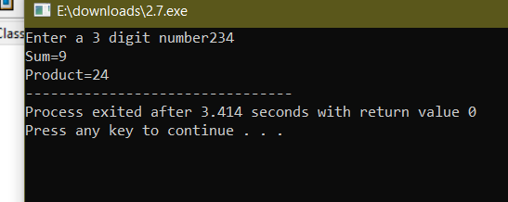

**8. WAP to find the size of various primitive data types used in C such as int, float, double and char.**

**INPUT**

#include<stdio.h>

main()

{

int a;

float b;

double c;

char d;

printf("Enter a integral number\n");

scanf("%d",&a);

printf("Enter a floating number\n");

scanf("%f",&b);

printf("Enter a double number\n");

scanf("%lf",&c);

printf("Enter a char \n");

scanf(" %c",&c);

printf("Int=%d\n",sizeof(a));

printf("Float=%d\n",sizeof(b));

printf("Double=%d\n",sizeof(c));

printf("Char=%d\n",sizeof(d));

return 0;

}

**OUTPUT**

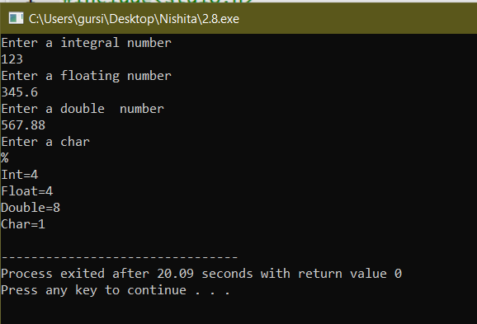

**Lab Assignment 3**

Question 1)

#include<stdio.h>

/*question 1-Disintegration of digits of a number*/

int main()

{

int a;

printf("\nEnter any three digit number of your choice");

scanf("%d",&a);

int b=a%100;

int c=b%10;

printf("\n%d",a);

printf("\n%d",b);

printf("\n%d",c);

return 0;

}

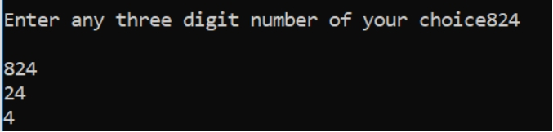

Question 2)

#include<stdio.h>

#include<math.h>

/*question 2-checking if a number is armstrong or not?*/

int main()

{

int a;

printf("\nEnter any three digit number of your choice");

scanf("%d",&a);

int b=a/100;

int c=a%100;

int d=c/10;

int e=c%10;

int n=3;

int s=pow(b,n)+pow(d,n)+pow(e,n);

printf("\n%s",(a==s)?"The number is an armstrong number":"The number is not an armstrong number");

return 0;

}

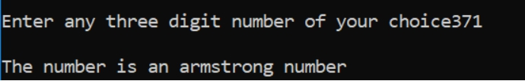

#include<stdio.h>

#include<math.h>

/*question 2-checking if a number is automorphic or not?*/

int main()

{

int a;

printf("\nEnter any number of your choice");

scanf("%d",&a);

int b=a*a;

int c=b%10;

printf("\nThe square of the number is %d",b);

printf("\n%s",(a==c)?"The number is an automorphic number":"The number is not an automorphic number");

return 0;

}

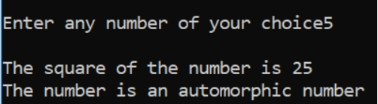

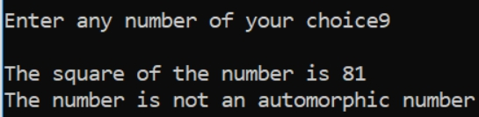

Question 3)

#include<stdio.h>

#include<math.h>

/*question 3-degrees to radians*/

int main()

{

float a;

printf("\nEnter any angle in degrees");

scanf("%f",&a);

float r=a*3.14/180.0;

float s=sin(r);

float c=cos(r);

printf("\nthe angle in\ndegrees=%f\tradian=%f\tsin()=%f\tcos()=%f",a,r,s,c);

return 0;

}

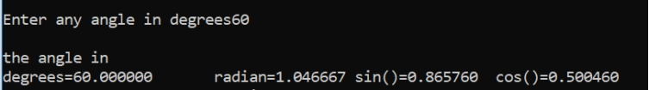

Question4)

#include<stdio.h>

#include<math.h>

/*question 4-largest and smallest*/

int main()

{

int a,b,c;

printf("\nEnter 3 numbers of your choice");

scanf("%d%d%d",&a,&b,&c);

int big=a>b?(a>c?a:c):(b>c?b:c);

int sm=a<b?(a<c?a:b):(b<c?b:c);

printf("\nthe largest number is %d",big);

printf("\nthe smallest number is %d",sm);

return 0;

}

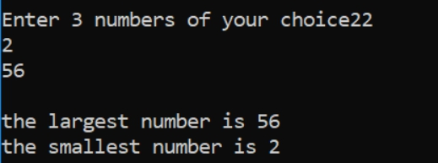

Question 5)

#include<stdio.h>

#include<math.h>

/*question 5-reversing the digits*/

int main()

{

int a;

printf("\nEnter any three digit number of your choice");

scanf("%d",&a);

int b=a/100;

int c=a%100;

int d=c/10;

int e=c%10;

printf("\nthe reversed number is %d%d%d",e,d,b);

return 0;

}

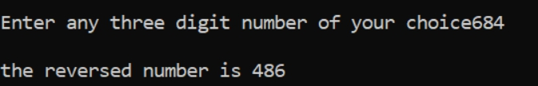

Question 6)

#include<stdio.h>

/*question 6-seperating of digits from float to int*/

int main()

{

float a;

printf("\nEnter any number of your choice with maximum 3 didgits before the deicmal point");

scanf("%f",&a);

int b=a;

int c=b/100;

int d=b%100;

int e=d/10;

int f=d%10;

printf("\nthe original number is %f",a);

printf("\n%d\n%d\n%d",f,d,b);

return 0;

}

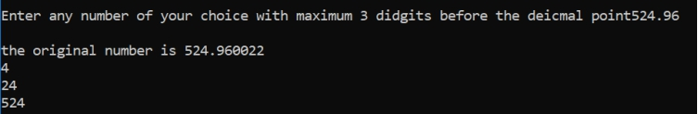

**Lab Assignment 4**

question 1)(a)

#include<stdio.h>

/*finding largest number*/

int a;

int b;

int c;

int main()

{

printf("Enter any three numbers of your choice");

scanf("%d%d%d",&a,&b,&c);

if(a>b)

{

if(a>c)

{

printf("the largest number is %d",a);

}

else

{

printf("the largest number is %d",c);

}

}

else

{

if(b>c)

{

printf("the largest number is %d",b);

}

else

{

printf("the largest number is %d",c);

}

}

return 0;

}

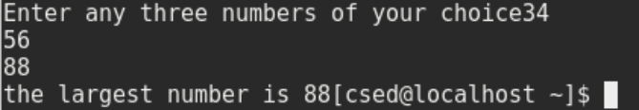

#include<stdio.h>

/*finding largest number*/

int a;

int b;

int c;

int main()

{

printf("Enter any three numbers of your choice");

scanf("%d%d%d",&a,&b,&c);

if(a>b&&a>c)

{

printf("the largest number is %d",a);

}

else if(a>b&&b<c)

{

printf("the largest number si %d",c);

}

else if(a<b&&b>c)

{

printf("the largest number is %d",b);

}

else

{

printf("the largest number is %d",c);

}

return 0;

}

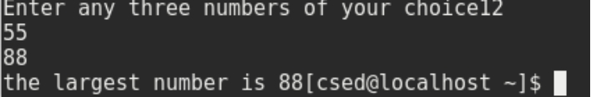

question 1)(b)

#include<stdio.h>

/*checking a digit or alphabet*/

int main()

{

char a;

printf("enter a digit or any character of your choice");

scanf("%c",&a);

if(a>='a' && a<='z')

{

printf(" lower case letter");

if(a=='a'||a=='e'||a=='i'||a=='o'||a=='u')

printf("it is a vowel");

else

printf("it is a consonant");

}

if(a>='A' && a<='Z')

printf("upper case letter");

if(a>='0'&&a<='9')

{

if(a%2==0||a%5==0)

printf(" it is a digit divisible by 2 or 5");

else

printf("it is a digit not divisible by 2 or 5");

}

return 0;

}



Question2)

#include<stdio.h>

/*calculation of bill*/

int main()

{

int a,c,d,e,f,g,h,i,j;

char b[120];

printf("enter your customer ID number");

scanf("%d",&a);

printf("\nenter your name");

scanf( "%s",&b);

printf("\nenter the amount of units consumed");

scanf("%d",&c);

printf("\nCUSTOMER ID NO.\t %d",a);

printf("\nCUSTOMER NAME\t %s",b);

printf("\nUNITS CONSUMED\t %d",c);

if(c<200)

{

printf("\ncharge per unit is rs1.2/unit");

d=c*1.2;

if(d<100)

printf("\nbill is less than the least amount");

else

printf("\nthe total amount to be paid is %d",d);

}

else if(c>=200&&c<400)

{

printf("\ncharge per unit is rs1.5/unit");

e=c*1.5;

if(e<400)

printf("\nthe total bill amount to be paid is %d",e);

else

{

h=e*0.15+e;

printf("\nthe total bill after extra charge is %d",h);

}

}

else if(c>=400&&c<600)

{

printf("\ncharge per unit is rs1.8/unit");

f=c*1.8;

i=f*0.15+f;

if(f<400)

printf("\nthe total bill amount to be paid is %d",f);

else

printf("\nthe total bill after extra charge is %d",i);

}

if(c>=600)

{

printf("\ncharge per unit is rs2/unit");

g=c*2;

if(g<400)

printf("\nthe total bill amount to be paid is %d",g);

else

{

j=g*0.15+g;

printf("\nthe total bill after extra charge is %d",j);

}

}

return 0;

}

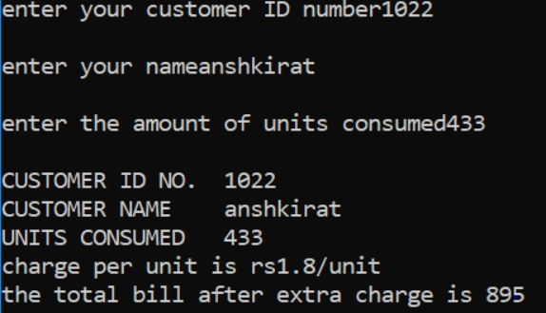

Question 3)

#include<stdio.h>

/*grade telling*/

int main()

{

char a;

printf("which grade have you secured? E,V,G,A or F?");

scanf("%c",&a);

if(a=='E'||a=='e')

printf("\nyou have secured EXCELLENT grade");

else if(a=='V'||a=='v')

printf("\nyou have secured VERY GOOD grade");

else if(a=='G'||a=='g')

printf("\nyou have secured GOOD grade");

else if(a=='A'||a=='a')

printf("\nyou have secured AVERAGE grade");

else

printf("\nyou have FAILED");

return 0;

}

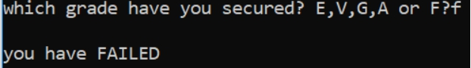

Question 4)

#include<stdio.h>

/*weather telling*/

int main()

{

float a;

printf("enter the temperature in degree celsius");

scanf("%f",&a);

if(a<0)

printf("\nthe weather is FREEZING");

else if(a>=0&&a<=10)

printf("\nthe weather is VERY COLD");

else if(a>10&&a<=20)

printf("\nthe weather is COLD");

else if(a>20&&a<=30)

printf("\nthe weather is NORMAL");

else if(a>30&&a<=40)

printf("\nthe weather is HOT");

else

printf("\nthe weather is VERY HOT");

return 0;

}

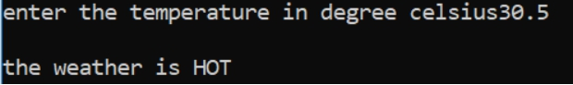

Question 5)

#include<stdio.h>

/*eligibility for admission*/

int main()

{

float m,c,p;

printf("enter your marks in maths,chemistry and physics respectively");

scanf("%f""%f""%f",&m,&c,&p);

if(m>=65&&c>=60&&p>=55)

{

if(m+c+p>=190||m+c>=130)

printf("\nthe candidate is ELIGIBLE for admission");

else

printf("\nthe candidate is NOT ELIGIBLE for admission");

}

else

printf("\nthe candidate is NOT ELIGIBLE for admission");

return 0;

}

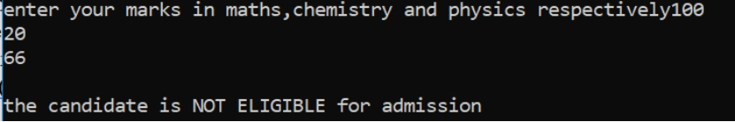

Question 6)

#include<stdio.h>

/*checking whether a number is a palindrome or not*/

int main()

{

int a,b,c,d,e,f;

printf("enter a three digit number \n");

scanf("%d",&a);

b=a/100;

c=a%100;

d=c/10;

e=c%10;

f=(e*100)+(d*10)+b;

if(a==f)

printf("\nthe number is a PALINDROME");

else

printf("\nthe number is NOT A PALINDROME");

return 0;

}

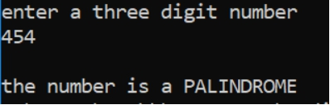

Question 7)

#include<stdio.h>

/*calculation of gross salary of an employee*/

int main()

{

int a;

printf("enter your salary \n");

scanf("%d",&a);

if(a<=10000)

{

int b=(a*0.2)+(a*0.8)+a;

printf("\nHRA=20%%\nDA=80%%\nhence,your gross salary is %d",b);

}

else if(a>10000&&a<=20000)

{

int c=(a*0.25)+(a*0.9)+a;

printf("\nHRA=25%%\nDA=90%%\nhence,your gross salary is %d",c);

}

else

{

int d=(a*0.3)+(a*0.95)+a;

printf("\nHRA=30%%\nDA=95%%\nhence,your gross salary is %d",d);

}

return 0;

}

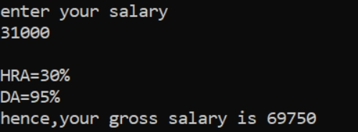

Question 8)(part a)

#include<stdio.h>

/*checking if a triangle is possible or not*/

int main()

{

float a,b,c;

printf("enter any three angles of a triangle of your choice \n");

scanf("%f""%f""%f",&a,&b,&c);

float sum=a+b+c;

if(a>0&&b>0&&c>0)

{

if(sum=180)

printf("\nthe triangle is possible");

else

printf("\nthe triangle is not possible");

}

else

printf("\nthe triangle is not possible");

return 0;

}

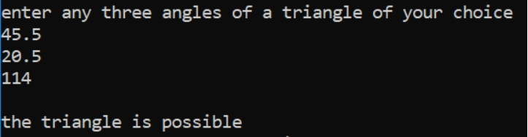

Question 8)(part b)

#include<stdio.h>

/*checking if a triangle is possible or not*/

int main()

{

float a,b,c;

printf("enter any three sides of a triangle of your choice \n");

scanf("%f""%f""%f",&a,&b,&c);

if(a>0&&b>0&&c>0)

{

if(a+b>c&&b+c>a&&a+c>b)

printf("\nthe triangle is possible");

else

printf("\nthe triangle is not possible");

}

else

printf("\nthe triangle is not possible");

return 0;

}

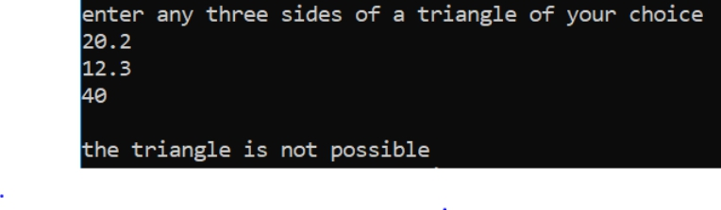

Question 8)(part c)

#include<stdio.h>

/*checking the type of triangle*/

int main()

{

float a,b,c;

printf("enter any three sides of a triangle of your choice \n");

scanf("%f""%f""%f",&a,&b,&c);

if(a>0&&b>0&&c>0)

{

if(a==b&&b==c&&c==a)

printf("\nthe triangle is EQUILATERAL");

else if(a==b||b==c||c==a)

printf("\nthe triangle is ISOSCELES");

else

printf("\nthe triangle is SCALENE");

}

else

printf("\nthe triangle is not possible");

return 0;

}

